SETTING UP:

- Hook up suitable size tractor
Recommended: 18T 150 – 220 HP

- Plug in remotes:
2 hoses for auger drive
2 hoses for auger ram

Test to make sure they operate the correct way, mark breakaways and record the correct position of the controls.

- Make sure tyres are inflated to correct pressure - 225KP

- Connect PTO shaft to tractor which drives discharge auger.

- Floor Auger: - The floor auger may need to be turned off when field bin or truck is full and you need to travel some distance to fully empty chaser bin. Also to empty main auger to be able to lower it to transport position for safe travel

SERVICE:

Grease: There are 4 bearings that need greasing every day.

1 grease point in the centre fold that needs greasing every 4 hours

OPERATION:

When operating the discharge auger, only allow it to fold and unfold at slow speed or damage may occur.

Before operating, do a position check while not travelling to determine a working position. While working header driver should maintain two-way contact.
Every situation is different but for most places it is best to travel towards field bin while being filled from harvester, so that when you have a full bin you don’t have very far to go with a full load. It is best when bin needs to be emptied that you pull up to field bin, put out unloading auger move into right position and start the main auger, then speed up tractor engine to an appropriate discharge speed.

CLEAN OUT:

To completely clean out bin, open drop doors under bin to allow all grain to fall to ground. Put back and use over centre catches to secure doors firmly.

SAFETY:

NEVER climb into bin while it is working.
Keep hands and feet away from moving parts.
Always replace guards if removed for maintenance.
Remember hydraulic hoses are under pressure while working so be careful when using hydraulics.
Turn off bin and tractor when carrying out work on bin.
If you ever come into contact with power lines, the safe way to dismount is to turn off machinery and jump well clear without touching machine and ground at the same time and contact authority to clear machine.
Travel at a safe speed appropriate to ground conditions so as to eliminate any bounce. Excessive speed will cause damage to structure through metal fatigue.

P.T.O. MODELS:

On the models with PTO drive, the machine has a gearbox to drive the main discharge auger allowing the operator to control the speed of unloading through the tractor revs. The floor auger is driven by a hydraulic motor which allows the operator to keep the discharge auger full.

This system has the advantage over the fully hydraulic one that it eliminates problems due to hydraulics being worn or too hot.

Grease Nipple

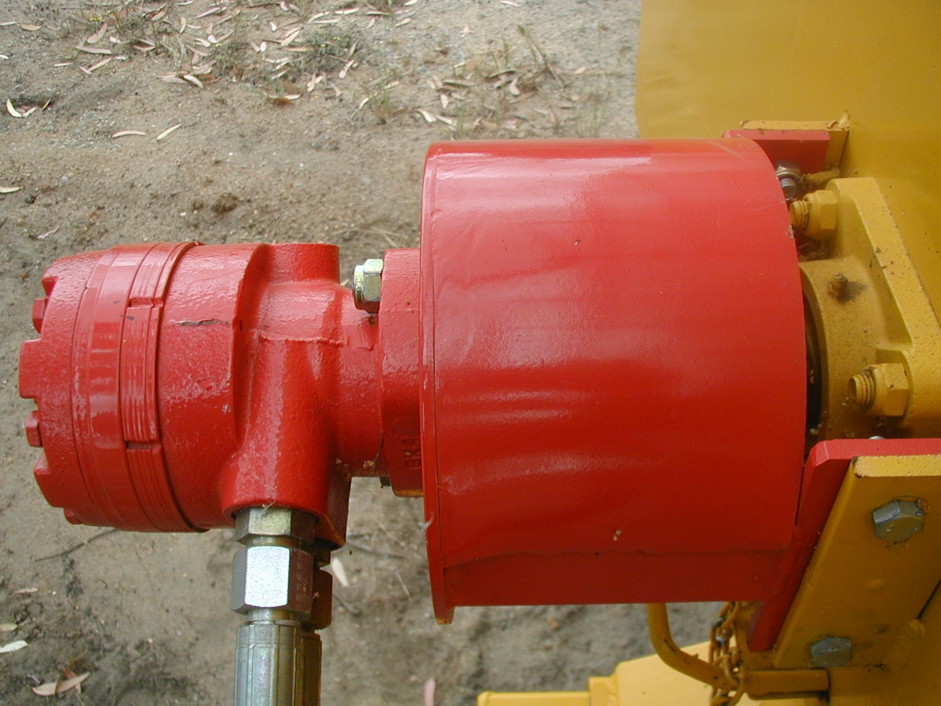

MCDOUGALL CHASER BIN

Model: ..………………………………………………………………….

Serial No: ………………………………………………………………..

Date of Purchase: ………………………………………………………..

Description of goods: …………………………………………………….

……………………………………………………………………………

……………………………………………………………………………

……………………………………………………………………………



